Simple Texture mapping tutorial

Hello, welcome to my second tutorial.

Tools used for this is: Anim8or, PaintShop Pro 5
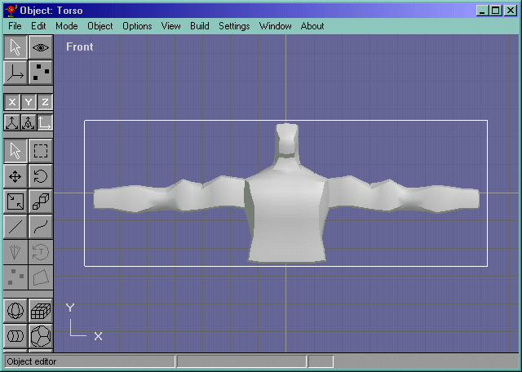Download the Texturemapped Torso
Here is a simple guy I modeled in anim8or just to use as a guide in this texture mapping tutorial.
To start texture mapping this guy, do a screenshot of him.(Above the insert key.) Oh yeah, select the object first so that you can see the "bounding boxes"
Ok, now open up PaintShop Pro and paste the image(ctrl+v). It is going to be zoomed out a bit, so select the general area of the model(outside of the white lines though.) With the srop tool, select the exact edges of that bounding box.(They should turn black) Open up the tools properties panel and there should be a button that says "Crop Image". Click that.
Now paint it till your hearts' desire!
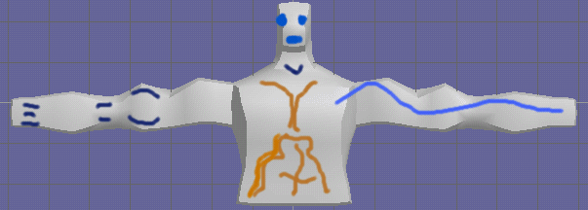
Ok, now open up Anim8or and open the torso model(you can download it at the top of the page.) Now goto Settings->Component->Texture UV. If your in the front view, Select the z axis and hit ok. Now load up the texture and hit apply.
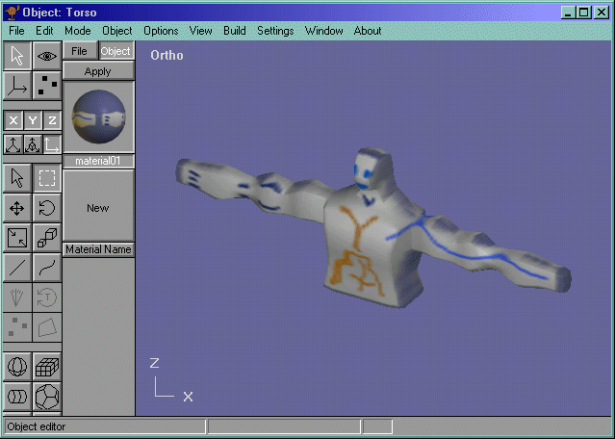
And youre done!
Ok, there are a few things about selecting the axis to apply uv coords in anim8or. First, the texture map has to corespond to the view you are mapping it too(duh, but some people dont know that.) In the front view, there is a little diagram of the axes, y and x. The z coordinate iscoming out of the screen. When you select the z coordinate for applyign uv coords, it applys them on the model facing the z direction. So if you wanted to texture map the model from the top, all you have to do is al the steps above, but take a screen capture from above, and apply to the,....what axis? The y axis. ;-)

